**Project Proposal**

**CSCI 5920**

**Team Member:** Devish Mundra

**Game Title:** Knock Down the Cans (An Augmented Reality Game for Mobile Devices)

**Game Description**

**Introduction:**

You can be a sniper and knock down zombies or the enemy in cold blood. Or you can shed a violent steak inside you and just knock down a few cans. If you ever played in the alleys and backyards of your childhood, you probably have piled up a few Coke cans and tried your aim with a rock or a tennis ball. I know I have, that’s why the simplicity of it all drew me to design this game in Augmented Reality.

**Description:**

The idea of this game is to recreate the fun carnival game in augmented reality for mobile devices. The game starts by flicking a ball at some canes arranged in front. You get five shots and two balls at first to rack up a score as the arrangement of cans progressively changes as you progress ahead. The goal is always to beat your previous score … and that’s where a bit of addiction creeps in. The design I will be using is more focused on the player control, and level design.

**Key Features:** The key features of my game Knock Down the Cans are:

* **Gameplay Control:** You need to swipe and hold to release the ball towards the cans.
* **Power Meter:**  There will be a power meter on the screen that indicates how powerful the shot would be.
* **Level Divisions:** The game is divided into levels. In each level, the player needs to clear all the metal cans by hitting them, so they fall and hit the ground. Each level has a different look and different can arrangement. For example, the exploding cans can explode and hit any can around a small radius and the ‘Extra Ball’ does what its name suggests, give you an extra ball.
* **Level Unlock:**  After you finish each level, next level gets unlocked.
* **Timer:** Timer is used to track the time taken to complete each level.
* **Scoreboard:** A scoreboard is used to count the score based on number of balls taken to hit the cans. Less number of balls, the more the score.
* **Placing and Positioning Assets:** Stationary AR objects need to stick to one point in each environment. This can be something concrete such as a wall, floor, or ceiling, or it could be suspended somewhere in midair. Whatever the case, placing means these objects stay where they're positioned. Even when users are in motion.
* **Scale and Size of Assets:**  A well-constructed AR experience will incorporate objects that are not only appropriately placed but will look different if you stand right next to it, below it, above it, or view it from afar.
* **Occlusion:** As this is an AR based game the AR objects must play by the rules of occlusion if we want them to seem real.AR hardware must be aware of essentially every single object in its environment. It needs to understand that there is a desk, a chair, and a table next to a bookcase, a vase, and a television. When the camera of the device moves the balls and cans should get occluded.
* **Lighting for Increased Realism:** Just like a real-world object, objects in AR need to respond to different patterns of lighting to make sense in our minds. The colors, shading, and shadows cast by these objects all need to behave properly both in the initial lighting of a scene and in the case of a lighting change.

**Genre:** Puzzle Game

The is a fun game that focus on hitting the cans as the level advances the game becomes more complex to knock down the cans.

**Platform(s):**

**Hardware Requirements:**

**Operating System** Android 7.0 or Later, IOS 11.0 or Later

**Processor** Snapdragon, Apple A10 Fusion

**Memory** 2 GB Minimum

**Software Requirements:**

**Operating System** Android Lollipop, IOS 11.0

**A brief discussion on** level design, scoring/winning system, obstacles (when applicable)

* **Make it more realistic:** The game is divided into levels, each level. In each level, the player needs to clear all the metal cans by hitting them, so they fall and hit the ground. Each level has a different look and different can arrangement. Some levels have moving parts that are designed to stop you from hitting the cans.
* **Scoring Points:** The player has only three balls to try to clear the levels. Some levels have more than three cans, so the player is required to pay attention to how the level was designed to make sure it hits the right bucket so he can have enough balls to clear up the entire level. At the end of each round, you get to see the current level score, time bonus, balls left, the total score and a 3-star ranking based on the number of balls it took you to clear up the cans**.** After you finish the round, you can then unlock the next round and so on.
* **Spatial Sound:** I’m going to add light continuous music for each level. In addition to that each time when the ball hits the can appropriate sound is made. If the target is missed an appropriate sound will be added.

**Supplement Concept Art**

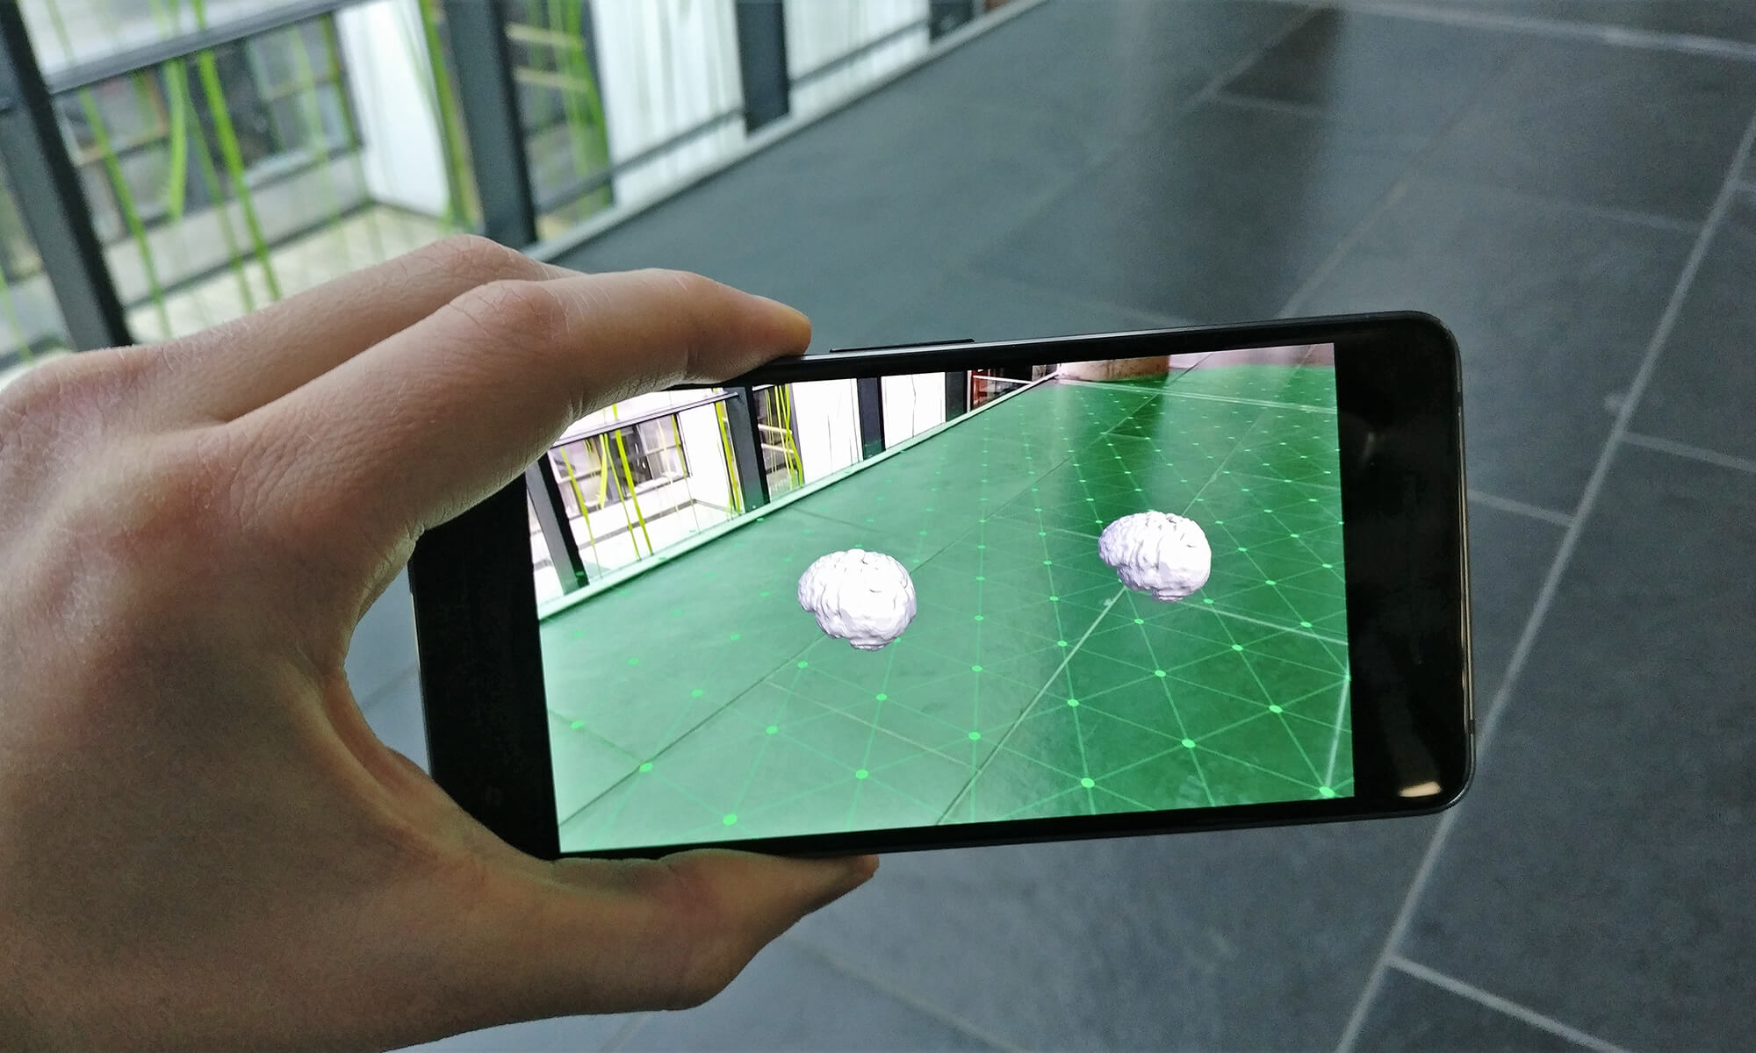

Fig 1: Plane Detection Augmented Reality

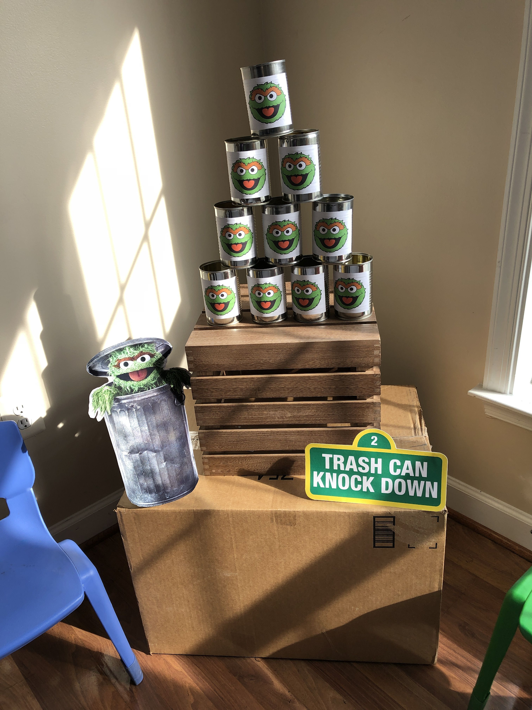

Fig: 2 Basic Concept

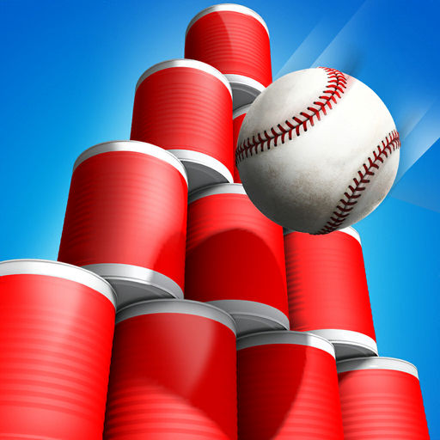

Fig 3: Ball hitting the cans

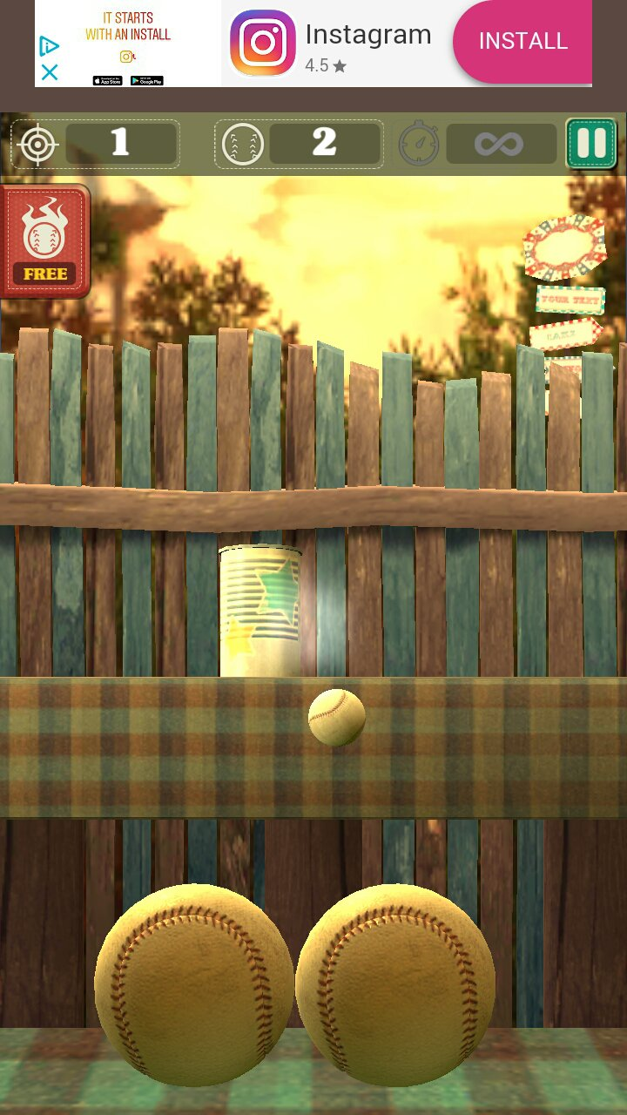

Fig 4: Screen with Score Board

**Layered Development Scheduled**:

|  |  |  |  |
| --- | --- | --- | --- |
| **Cycle** | **Task** | **Timeline** | **Assigned** |
| Come Up with a Game Idea | Design Game | **Start**:09/29  **End**:10/2 | Devish Mundra |
| Develop Concept | Game Mechanics & Setting | **Start**:10/2  **End**:10/12 | Devish Mundra |
| Create Prototypes | Creating a Playable Prototype for Target Platform | **Start**:10/13  **End**:10/23 | Devish Mundra |
| Create Prototypes | Game Control  Power Meter  Occlusion | **Start**:10/24  **End**:11/1 | Devish Mundra |
| Create Prototypes | Movable Objects  Timer  Score Board | **Start**:11/2  **End**:11/10 | Devish Mundra |
| Testing | Test the Game | **Start**:11/11  **End**:11/15 | Devish Mundra |
| Deployment and Documentation | Deploying on Android or IOS device | Start:11/16  End:11/21 | Devish Mundra |

**Flow Diagram:**

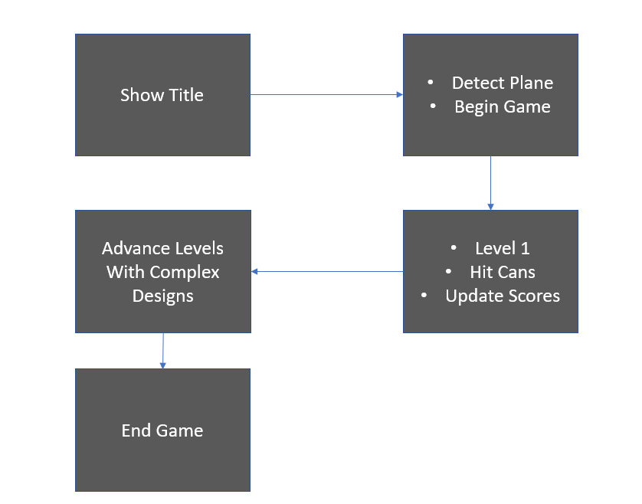

**Assessment:**

Main strength of the game will be:

* The strength of the game will be the hit the cans with minimum number of balls

What part is going to be the coolest?

* As it is an AR based game hitting the cans in the real-world environment and sounds and graphics

What virtual world should the system simulate?

* It’s going to be in the real world with virtual objects

What criteria should be used to judge if your design is a success or not?

* If I’m not able to make all the features working then we at least can finish the design layout of all the resources (cans, balls, movable objects) that I planned.

**References:**

[1] <https://developers.google.com/ar/develop/developer-guides/design-guidelines>

[2] <https://developer.apple.com/documentation/arkit>

[3] <https://docs.unrealengine.com/en-US/Platforms/AR/index.html>

[4] [Augmented Reality for Developers](https://books.google.com/books?hl=en&lr=&id=8xhKDwAAQBAJ&oi=fnd&pg=PP1&dq=augmented+reality+arkit&ots=ve5rK_mURv&sig=kAa97VAhHKkNfKRjGUjUYEislEg#v=onepage&q=augmented%20reality%20arkit&f=false)